**Lab 17: Android Progress Bar**

# **Introduction**

# To display the progress of work being done, such as downloading files or assessing work status, we can use the Android progress bar dialogue box. ProgressDialog class provides following methods

# setProgress()

# setMessage()

# setProgressStyle()

# setMax(), show()

# etc

# The Progress Dialog has progress bar range 0 to 10000

**Let’s get Started:**

In this exercise we will learn to implement Progress Bar in Android App.

**Step 1: Create a New Project in Android Studio as shown below**

**Step 2: Select Empty Activity as shown below**

**Step 3: Provide a Project Name as shown below**

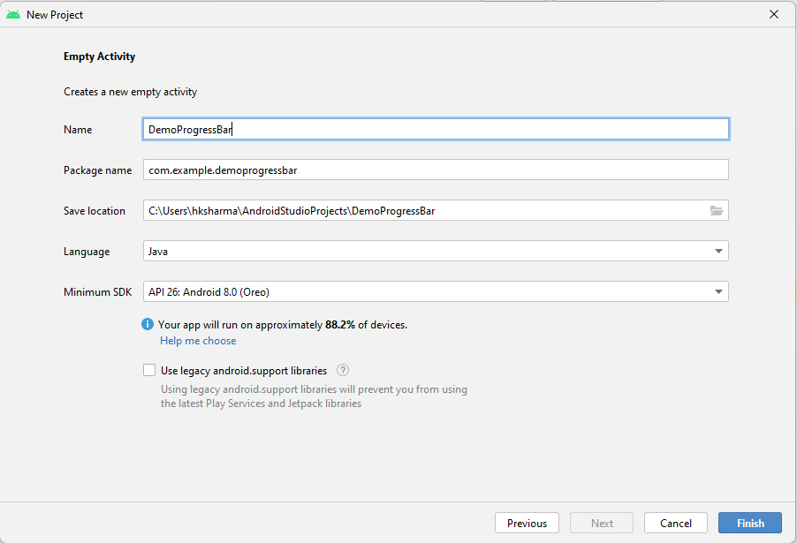

**Step 4: Update MainActivity.java as per the code given below**

**package** com.example.demoprogressbar;  
  
**import** androidx.appcompat.app.AppCompatActivity;  
  
**import** android.os.Bundle;  
**import** android.view.View;  
**import** android.widget.Button;  
**import** android.widget.ProgressBar;  
  
**import** java.util.Timer;  
**import** java.util.TimerTask;  
  
**public class** MainActivity **extends** AppCompatActivity {  
 ProgressBar **pb1**, **pb2**;  
 Button **btn1**;  
 **int counter**=0;  
  
 @Override  
 **protected void** onCreate(Bundle savedInstanceState) {  
 **super**.onCreate(savedInstanceState);  
 setContentView(R.layout.***activity_main***);  
 **pb1**=findViewById(R.id.***pb1***);  
 **pb2**=findViewById(R.id.***pb2***);  
 **btn1**=findViewById(R.id.***btn1***);  
 **btn1**.setOnClickListener(**new** View.OnClickListener() {  
 @Override  
 **public void** onClick(View view) {  
 **pb1**.setVisibility(View.***VISIBLE***);  
 **pb2**.setVisibility(View.***VISIBLE***);  
 Timer timer= **new** Timer();  
 TimerTask timerTask= **new** TimerTask() {  
 @Override  
 **public void** run() {  
 **counter**++;  
 **pb1**.setProgress(**counter**);  
 **pb2**.setProgress(**counter**);  
 **if**(**counter**==100)  
 timer.cancel();  
 }  
 };  
 timer.schedule(timerTask,100,100);  
 }  
 });  
 }  
}

**Step 5: Activity_main.xml**

*<?***xml version="1.0" encoding="utf-8"***?>*<**LinearLayout xmlns:android="http://schemas.android.com/apk/res/android"  
 xmlns:app="http://schemas.android.com/apk/res-auto"  
 xmlns:tools="http://schemas.android.com/tools"  
 android:layout_width="match_parent"  
 android:layout_height="match_parent"  
 android:orientation="vertical"  
 tools:context=".MainActivity"**>  
  
 <**TextView  
 android:layout_width="wrap_content"  
 android:layout_height="wrap_content"  
 android:text="Hello World!"  
 app:layout_constraintBottom_toBottomOf="parent"  
 app:layout_constraintEnd_toEndOf="parent"  
 app:layout_constraintStart_toStartOf="parent"  
 app:layout_constraintTop_toTopOf="parent"** />  
  
 <**Button  
 android:id="@+id/btn1"  
 android:layout_width="match_parent"  
 android:layout_height="wrap_content"  
 android:text="start progres"** />  
  
 <**ProgressBar  
 android:layout_width="match_parent"  
 android:layout_height="wrap_content"  
 android:id="@+id/pb1"  
 android:visibility="gone"**/>  
 <**ProgressBar  
 android:layout_width="match_parent"  
 android:layout_height="wrap_content"  
 android:id="@+id/pb2"  
 style="@style/Widget.AppCompat.ProgressBar.Horizontal"  
 android:visibility="gone"**/>  
  
</**LinearLayout**>

**Step 5: Check Output on Android Emulator and it should look like as given below**

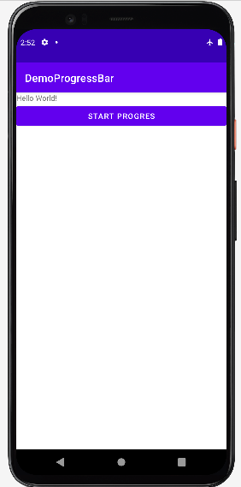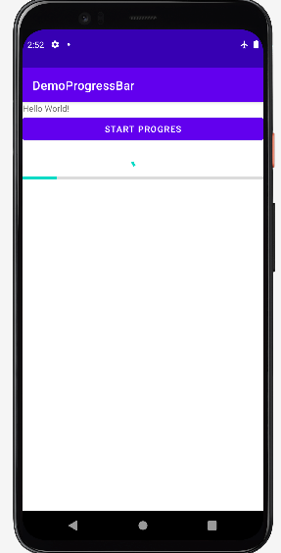

**Voila!!** We have successfully completed this lab.